Volunteer Wanted!!!
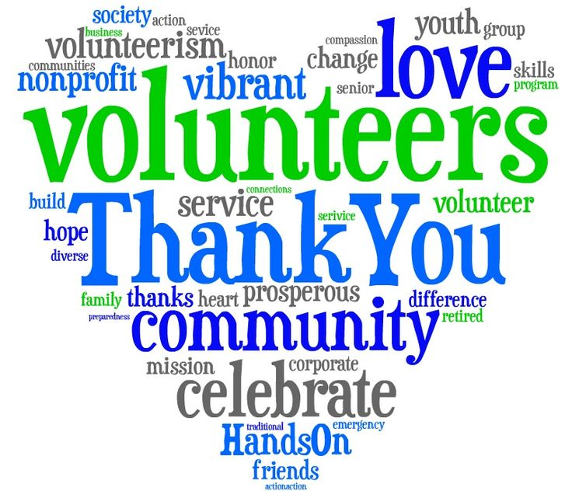

I love volunteers in our classroom. We welcome parents and grandparents!
If you are interested in helping, please fill out this form below.
Name:______________________ Phone # ________________
Email:___________________________________________________
Student Name:__________________________________________
I would love to help with: (Please check all that apply)

_____ Room Mom _____Making Copies
______ One-on-one Tutoring _____Reading with students
______ correcting papers
______ helping with art projects and class celebrations

When are you available? (Please Circle)
M T W TH F In the: Morning Afternoon

Comments:_______________________________________________________________________________________________________________________________________________________________________

